Date: ___________________ Day: ☐ M ☐ T ☐ W ☐ Th ☐F
My energy today:  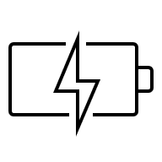  ☐ Super sleepy, hard to stay awake  ☐ Started off strong  ☐ Finished tired  ☐Focused, ready to learn  ☐ Other: _________________________ | My behavior today:  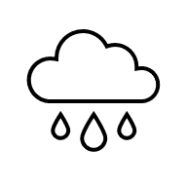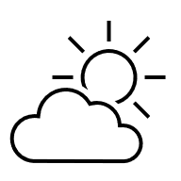  ☐ Silly, anxious, out of sorts  ☐ Down, low, tired, or sick  ☐ Grumpy or upset  ☐ Calm, cool, collected  ☐ Sunshine and rainbows – great day!  ☐ Other: _________________________
Homework:    ☐ None, enjoy your evening  ☐ Something due tomorrow  ☐ Something due this week  ☐ Long-term project  ☐ Extra practice  ☐ Other: _________________________   Let’s Chat:  ☐ Send me an email  ☐ Give me a call  ☐ I’ll be reaching out  ☐ Let’s meet! |  I ate:  ☐ Snack  ☐ Lunch  ☐ Other: _________________________  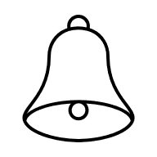 Reminders:  ☐ Low on lunch money  ☐ Bring extra clothes  ☐ Permission slip/ parent signature  ☐ Quiz/ test coming up  ☐ Check emails  ☐ Other: _________________________
Something to ask me about:_______________________________________________________
__________________________________________________________________________________
__________________________________________________________________________________
Something you should know: _____________________________________________________
__________________________________________________________________________________
__________________________________________________________________________________

